**Wrike Max Simms-Walker**

Wrike is a one hundred percent cloud based project management tool that's designed to simplify communication between coworkers.

-It consists of different categories to place tasks. For instance on the homepage there are category sections where users can place tasks that are in the backlog or overdue. There is also an activity stream on the right where we can see recent updates from team members, share files or share on status updates.

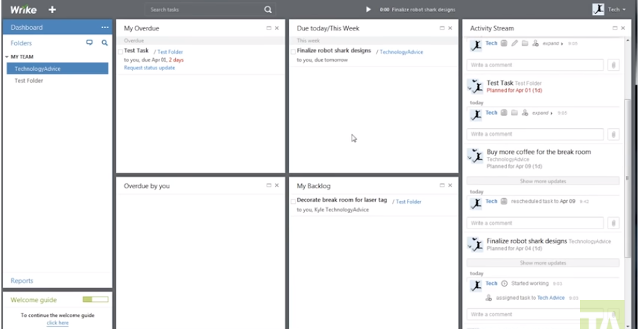

**Figure 1** Wrike Homepage

On the left hand side of the application there is a folder section that contains folders which serve as projects. There is a hierachy of folders that exist that contain different subsections in which new tasks can be added by clicking inside one of the folders. Also, users can click the white plus button at the top.

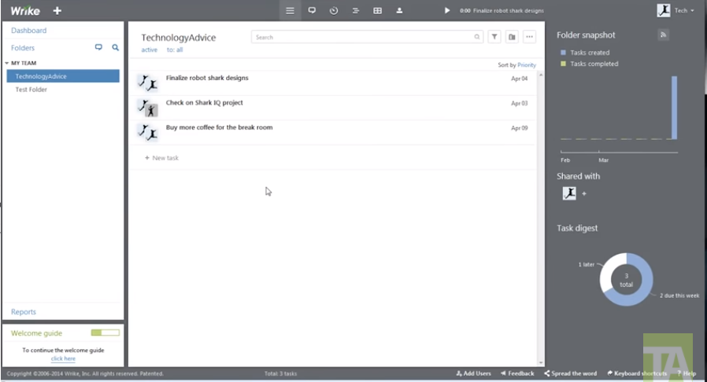

**Figure 2** Wrike folder section

If a task is clicked more details about that task can be viewed which can then be assigned to someone, the due date can then be changed. Furthermore, users can attach files and add dependencies or share he file with other people.

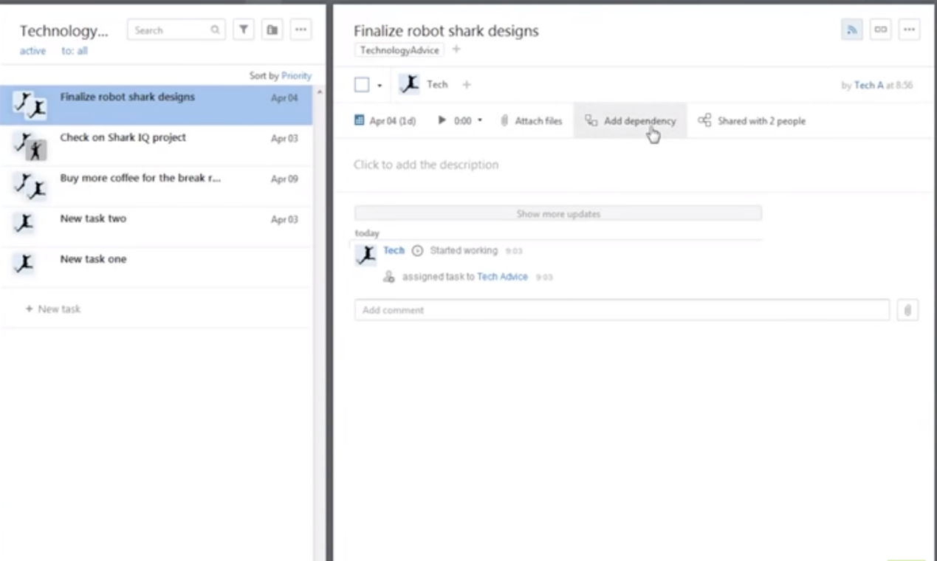

Wrike includes a time tracking feature in which users can track how long each task took to complete. All of that is then logged in an individual time log.

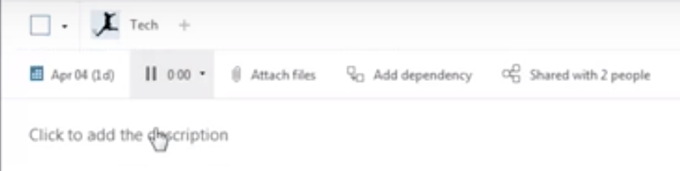

**Figure 3** Wrike time tracking feature

There is also a general activity timeline that can be used to better visualise the progress of projects throughout

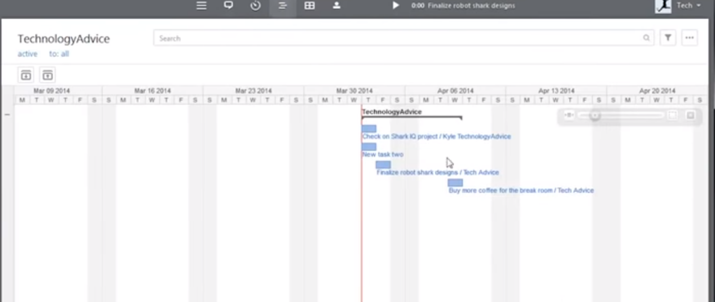

**Figure 4** Timeline feature

In addition there is a table feature that can be used to provide a better format of the tasks in a given project

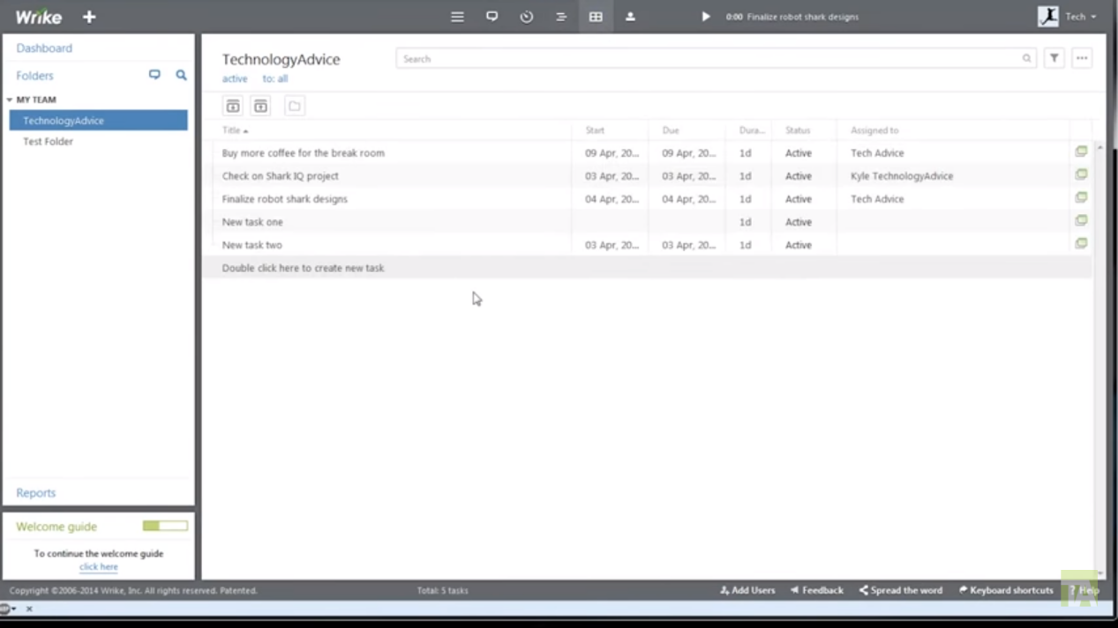

**Figure 5** Table feature

As well as a workloads feature where you can see each team member and what task each member has assigned to them.

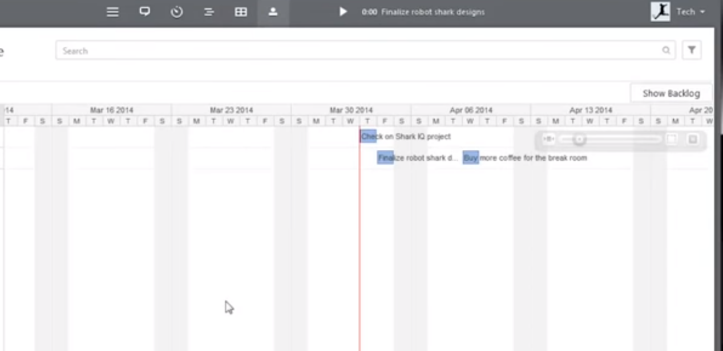

**Figure 6** Workloads feature

On the homepage Wrike includes a task digest on the right, showing how many tasks that are due as well as which tasks are backlogged and a folder snapshot which displays how many tasks have been created in the project versus how many tasks have been completed.

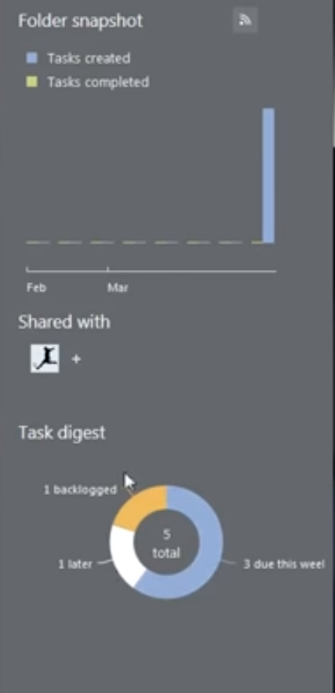

**Figure 7** Table digest and folder snapshot

Overall, wrike is an intuitive project management system with visual anaytics features as well as timetracking.

**References**

TechnologyAdvice. 2020. *Wrike Reviews | Technologyadvice*. [online] Available at: <https://technologyadvice.com/products/wrike-reviews/> [Accessed 15 August 2020].

Wrike. 2020. *Versatile & Robust Project Management Software | Wrike*. [online] Available at: <https://www.wrike.com/> [Accessed 15 August 2020].